TEAM ID: PNT2022TMID53558

UI FOR WATER TURBIDITY ANDPHVALUES

AIM:TO CREATE UI FOR DISPLAYING WATER TURBIDITY AND Ph VALUES.

REQUIREMENTS:IBM CLOUD,IBM WATSON IOT,NODE RED SERVICES.

UI:

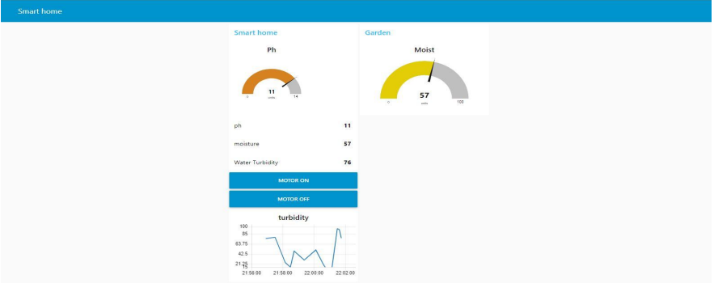

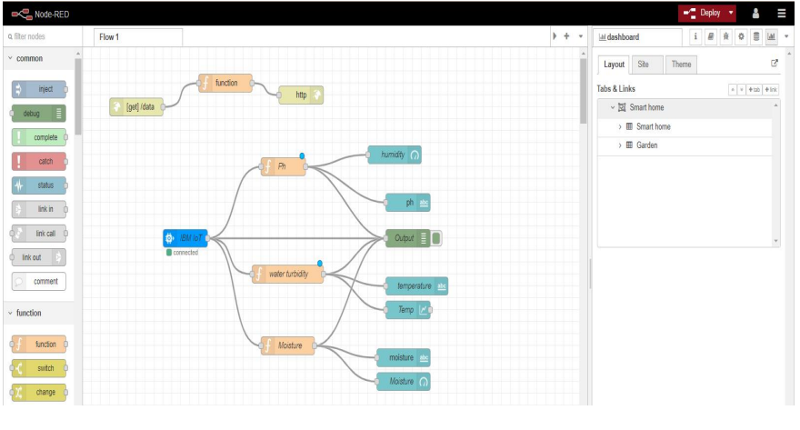

CONFIGURE THE APPLICATION FOR CONTROLLING MOTOR AND RECEIVE DATA FROM CLOUD

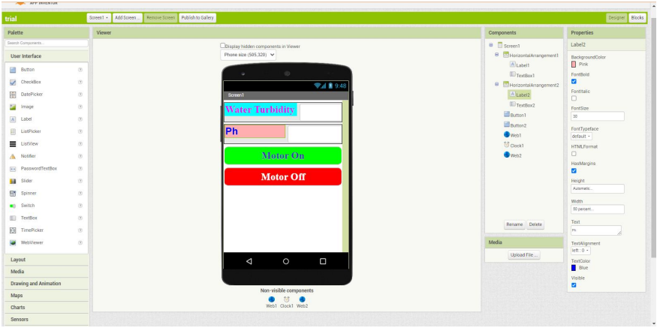

MOBILE APPLICATION:

